**IMPROVED VOGEL’S APPROXIMATION METHOD TO SOLVE FUZZY TRANSSHIPMENT PROBLEM**

**NUMERICAL EXAMPLE USED:**

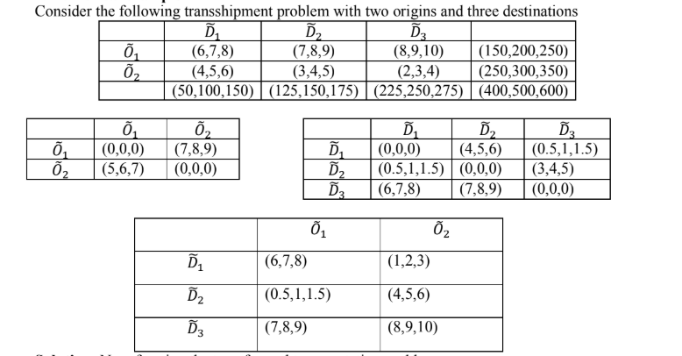

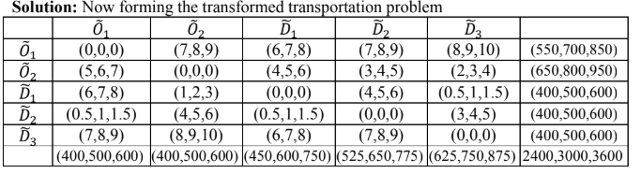

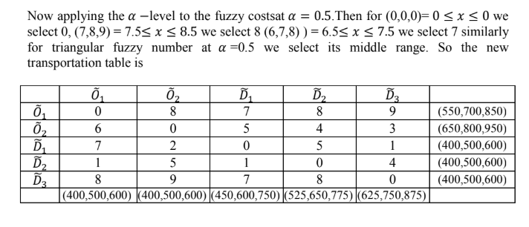

ALGORITHM COMPARISON

**APPLYING VAM**

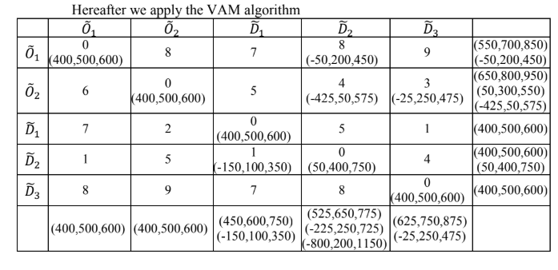

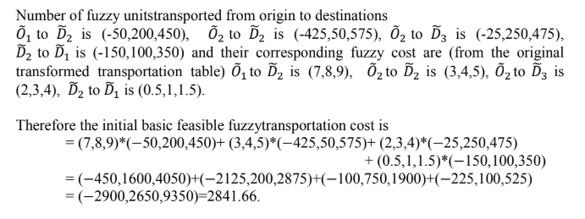

In VAM they have used a graded mean integration method to find the big or small fuzzy numbers. all the cost, supply and demand of the fuzzy transhipment problem are in fuzzy. So firstly, converting the fuzzy cost to #-level cost and then applying the Vogel’s approximation method. After getting the fuzzy initial solution and then they have Applied the improved Vogel’s approximation method for the same problem.

**APPLYING IVAM**

VAM was improved by using total opportunity cost (TOC) matrix and regarding alternative allocation costs. The TOC matrix is obtained by adding the row opportunity cost matrix and column opportunity cost matrix.

**Row opportunity cost matrix**: For each row, the smallest cost of that row is subtracted from each element of the same row.

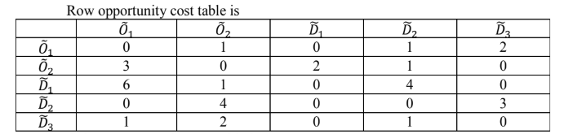

(Note: while selecting the smallest cost don’t consider the diagonal zero)

**Column opportunity cost matrix:** For each column of the original transhipment cost matrix the smallest cost of that column is subtracted from each element of the same column.

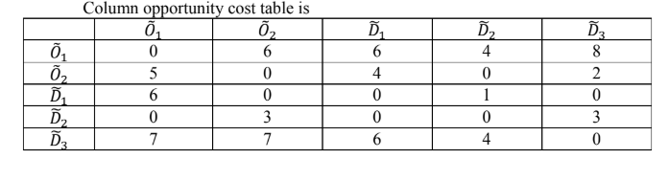 (Note: while selecting the smallest cost don’t consider the diagonal zero)

And thus, proposed algorithm is applied on the TOC matrix.

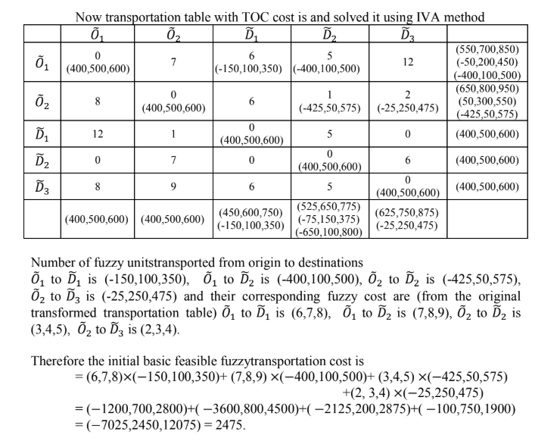

**2475 < 2841.66**

Thus IVAM performs better in finding out the optimal solution and reducing the cost.